District Policies/Regulations for Families
Please refer to the links for more information

Safe and Respectful Learning Environment | https://www.wcsdpolicy.net/pdf_files/board_policy/5700_Policy-SRLE-v6_FINAL.pdf
Student Behavior | https://www.wcsdpolicy.net/pdf_files/board_policy/5100_Policy-Student_Behavior-v7_Final.pdf
Student Bullying, Harassment | https://www.wcsdpolicy.net/pdf_files/administrative_regulations/5701-Reg-Student_Bullying-v4.2_FINAL.pdf
Gender Identity | https://www.wcsdpolicy.net/pdf_files/administrative_regulations/5161_Reg-Gender_Identify-v2.pdf
Student Dress Code | https://www.wcsdpolicy.net/pdf_files/administrative_regulations/5102_Reg-Dress_Code-v1.1.pdf
Student Uniforms (for Uniform Schools) | https://www.wcsdpolicy.net/pdf_files/administrative_regulations/5106%20Reg%20-%20Student%20Uniforms-Adoption%20Guidelines_School%20Site%20Policy_v5_FINAL.pdf
Homework | https://www.wcsdpolicy.net/pdf_files/board_policy/6154_Policy-Homework-v3.pdf
Plagiarism and Cheating Prohibited | https://www.wcsdpolicy.net/pdf_files/6642%20AP%20-%20Plagiarism%20and%20Cheating%20v3.pdf
Use of Personal Electronic Device by Students | https://www.wcsdpolicy.net/pdf_files/administrative_regulations/5810%20Reg%20-%20Cell%20Phones%20v1.1.pdf
Responsible Use and Internet Safety | https://www.wcsdpolicy.net/pdf_files/administrative_regulations/7211-Reg-RUA_Internet_Safety-v4.pdf
Student E-mail | hhttps://www.wcsdpolicy.net/pdf_files/administrative_regulations/5007-Reg-Student_Email-v3_FINAL.pdf
Student Attendance | https://www.wcsdpolicy.net/pdf_files/board_policy/5400_Policy-Student_Attendance_v5_Final.pdf
Service Animals | https://www.wcsdpolicy.net/pdf_files/administrative_regulations/7521-Reg-Service_Animals-v5.pdf
Transportation of Students | https://www.wcsdpolicy.net/pdf_files/administrative_regulations/7501_Reg-Transport_of_Students-v9.1_Final.pdf
Release of Students during School Hours | https://www.wcsdpolicy.net/pdf_files/5146%20Reg%20-%20Release%20of%20Students.pdf
Student Records and Information | https://www.wcsdpolicy.net/pdf_files/board_policy/5000_Policy-Student_Records-v3_Final.pdf
Student Activities (secondary) | https://www.wcsdpolicy.net/pdf_files/board_policy/5300-Policy-Activities-v2_Final.pdf
District Recognized Athletics (secondary) | https://www.wcsdpolicy.net/pdf_files/board_policy/5325-Policy-Rec_Athletics-v2_FINAL.pdf
Volunteer Screen and Background Checks | https://www.wcsdpolicy.net/pdf_files/administrative_regulations/1501_Reg-Volunteers-v1.pdf
Protocols for Visitors to District Property | https://www.wcsdpolicy.net/pdf_files/administrative_regulations/1506-Reg-Visitors-v3.pdf
Student Behavior Manual | https://www.wcsdpolicy.net/pdf_files/manuals/Student%20Behavior%20Administrative%20Procedures%20Manual%2021-22_v5.pdf
Emergency Updates (Code Red/Yellow) | https://www.washoeschools.net/alert

Marvin Moss Elementary School
Award Title | Who | Criteria | Award | Frequency | Presentation
Verbal Praise | All Staff | Displaying one of the “Marmot Pledge” components | Immediate positive verbal praise | As often as possible at appropriate times. | All areas of the campus
Marmot Moolah | All staff | Displaying Respectful, Responsible and Safe behavior | Immediate praise | Monthly – Marmot Store  Give Moolah as often as possible | All areas of the campus
Marmot Chirp | All staff | Any form of parent participation or communication  (attending activities, volunteering, required communication, etc) | Immediate praise | As often as possible | All areas of the campus
Marmot Burrow | All staff | Displaying “Marmot Moss Pledge” components as a whole class | Immediate praise | As often as possible | All areas of the campus
Academic Awards | Teachers | All A’s and all A’s &B’s in academics | Determined by the classroom teacher | Quarterly
Citizenship Award | Teachers | All A’s in Citizenship | Determined by the classroom teacher | Quarterly
Attendance Award | Teachers | Perfect Attendance | Determined by the classroom teacher | Quarterly
PBS Recognition System
Marvin Moss ES has adopted a school-wide positive behavior support program in order to establish norms for school behavior and encourage character development. The following expectations will be taught to students and reinforced by all school staff.

Marvin Moss Pledge:
I am an outstanding citizen. I am respectful, responsible and safe.

Students can earn Marmot Moolah for positive behavior at school and are able to shop monthly for prizes.

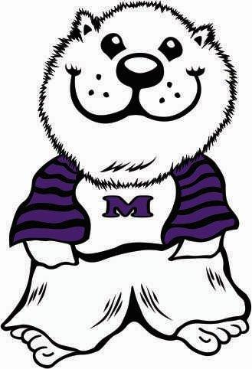
Marmots are outstanding citizens that can follow/burrow through the school expectations!

Area | We Are  Respectful | We Are  Responsible | We Are  Safe
Assembly | - Sit on pockets  - Voices off when presenter is talking | - Follow the quiet signal | - Keep hands and feet to yourself
Bathroom | - Go, flush, wash and leave  - Keep it clean  - Respect the property | - One person at a time in the restroom  - Report any problems | - Report any problems
Bus | - Keep the bus clean | - Stay in seat and face forward  - Keep the aisle clear | - Keep hands and  - Follow all safety and emergency procedures
Classroom | - Follow the classroom rules and directions of all those in authority.  - Be respectful | - Come to class on time  - Be prepared | - Keep your hands and feet to yourself
Exit and Enter | - Respect school property | - Exit only at wing doors  - Go directly to assigned areas | - Stay in your pick-up area until time to go  - Keep your hands and feet to yourself
Hallway | - Walk quietly | - Walk on the right side of the hallway  - Go straight to your destination | - Walk in a single file line with eyes forward  - Keep your hands and feet to yourself
Lunchroom | - Keep the lunchroom clean  - Use a six-inch voice | - Follow directions  - Follow the quiet signal and lunchroom procedures | - Keep your hands and feet to yourself
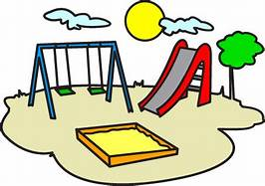
Marmots are outstanding citizens that can follow/burrow through the Playground Expectations!

We Are  Respectful | We Are  Responsible | We Are  Safe
Be a good sport.  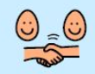 | Keep personal belongings at home.  (toys, bats, footballs)  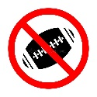 | Ask permission to leave the school playground. Play in the designated areas.  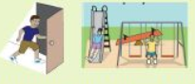
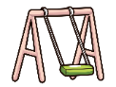  Take 20 swings when students are waiting for a swing. | Respond to time cues.  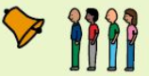  IE: Bell means time to line up | 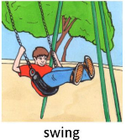  Swing back and forth on the swings sitting on our pockets.
Include others and ask others to play.  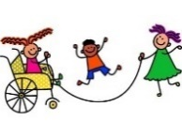 | Take pride and care on our school property.  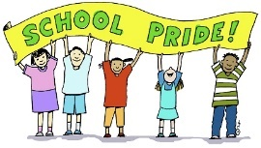 | 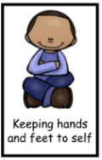  Play games that keep our hands/feet to self.
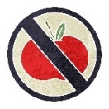  Eat food in the cafeteria or classroom. |   Safe Tagging - Light two finger touch, like butterfly wings, on the shoulder, upper arm or upper back. | 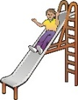  Go down the slide one at a time. Feet first and on your pockets.

